# CS 255 System Design Document Template

This template lays out all the different sections that you need to complete for Project Two. Each section has guidance to prompt your thinking. You will need to continually reference the interview transcript as you work to make sure that you are addressing your client’s needs. There is no required length for the final document. Instead the goal is to complete each section based on what your client’s needs are. Remove this note when you are finished, and replace all bracketed text with the relevant information.

## UML Diagrams

### UML Use Case Diagram

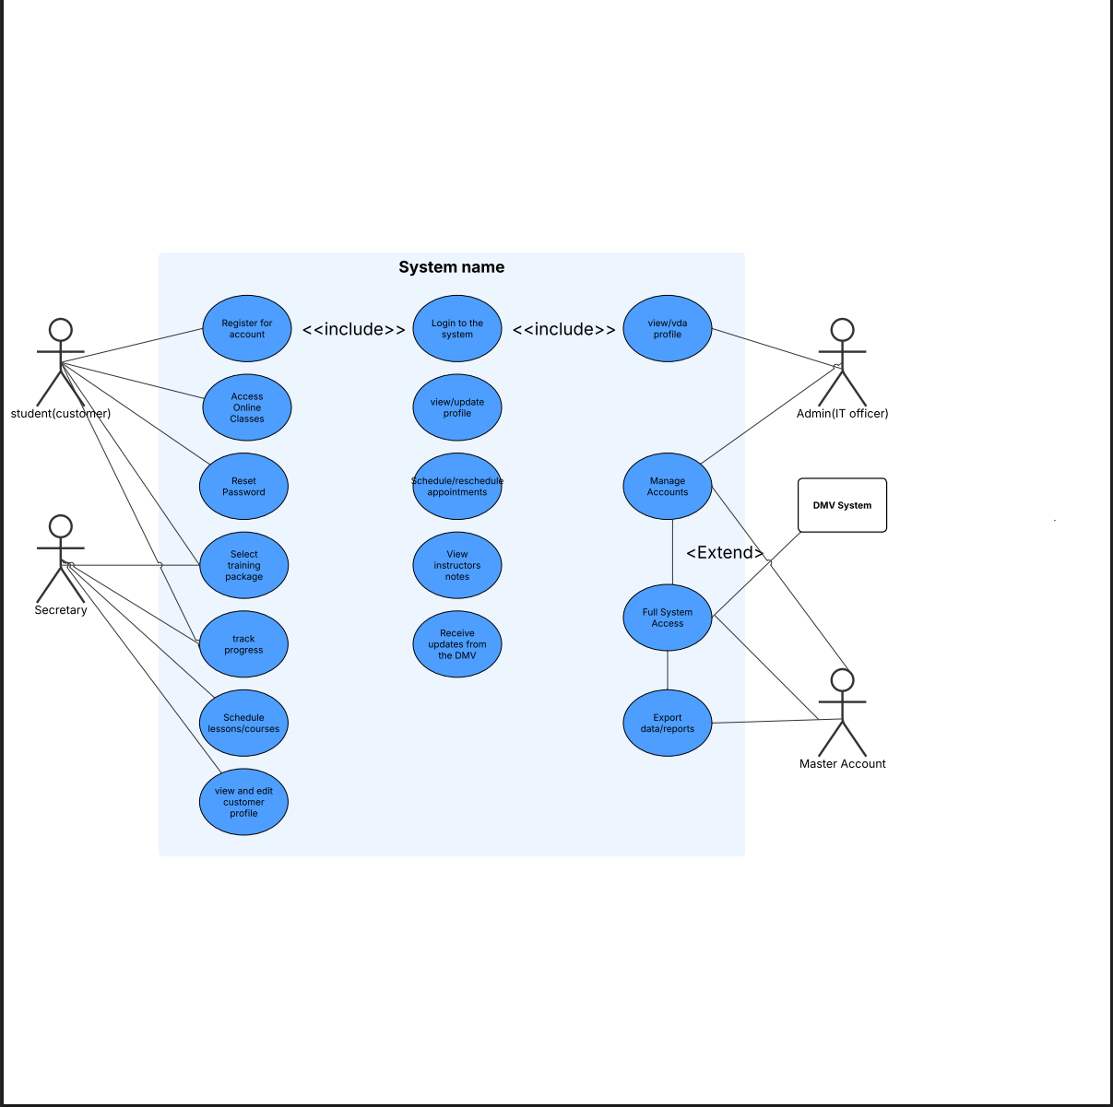

### UML Activity Diagrams

### UML Sequence Diagram

### UML Class Diagram

## Technical Requirements

*Based on the UML diagrams I created, my systems design requires a variety of specific software, hardware, and tools to support the functionality of the DriverPass system. With the hardware, users will need a basic device that give them internet and browser access such as a laptop, phone, or desktop. For hosting the backend and database, a cloud server is needed, with at least 16gb of ram and a multicore processor, and ssd storage. This setup would help make sure that the system can handle everything it needs to. On the software side the frontend can be built using standard web technologies like html, css, and javascript and possibly even a framework like react to help make the user interface a bit better. The backend would be developed with node.js and express. I would then use a relational database like Postgresql to store things such as user accounts, appointment details, and information on packages. Outside of all of that I would use tools like git for version control, and lucidchart for any further planning on expanding the system. The system would need to be hosted on a cloud platform such as AWS or Heroku as well.*